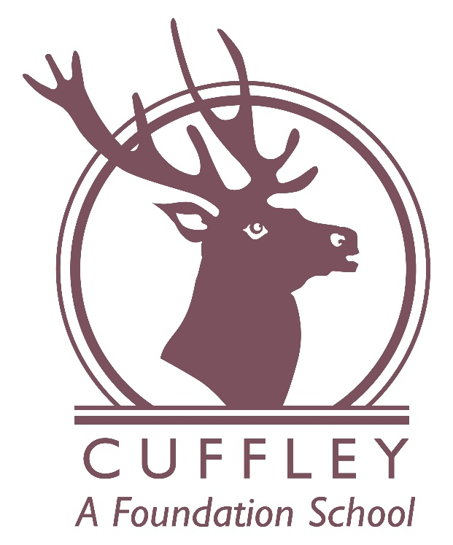

British Values

Ratified: November 2025
Chair of Governors: Marie Linnane
Review: November 2026

Introduction

The Department for Education have reinforced the need “to create and enforce a clear and rigorous expectation on all schools to promote the fundamental British Values of democracy, the rule of law, individual liberty and mutual respect and tolerance of those with different faiths and beliefs.”

At Cuffley School these values are taught through delivering a broad and balanced curriculum which appeals to, and challenges, pupils of all ages. The school also takes the opportunity to promote these values during class lessons, in assemblies and more explicitly in Personal Social Health Education and Religious Education lessons. We specifically teach British Values through our well-planned assembly schedule in which we make explicit which value we are teaching and how we ‘live’ it at Cuffley. Each British Value has an associated visual.
At Cuffley School we will actively challenge pupils, staff or parents expressing opinions contrary to fundamental British Values, including ‘extremist’ views.

Democracy

Democracy is an important aspect of our school ethos and plays an important role in the development of our school. Each year pupils complete their Class Charters. Each class has rights and responsibilities. Class rights are the rights to be safe, to learn and to play. Each class agrees the responsibilities associated with these, with all pupils able to contribute their views. Through the School Council, pupil questionnaires and pupil feedback, pupils are given a voice and an opportunity to effect change within the school and local community. Through the School Council pupils are taught about the democratic process through applying for The Communications Team and the subsequent anonymous voting systems.

Rule of Law

The importance of laws and rules is consistently reinforced and recognised by teachers and pupils alike. The pupils take an active role in deciding upon Class Charters as they start each academic year (see above). This helps them to understand that rules and laws both govern and protect us.

We have a Behaviour Policy, which is shared with the school community. This clarifies how behaviour is managed at Cuffley, with clear rewards and sanctions. Expectations of conduct and behaviour are regularly reinforced and opportunities are sought to praise positive choices.

In Key Stage 2, play leaders and referees are trained to take an active role in solving problems and assisting in the decisions made within games at lunchtimes. These responsibilities give pupils a deeper understanding of justice and accountability.

We are always keen to invite outside agencies, such as the police and fire service, health professionals and ‘people who help us’ into our school to help to reinforce the message of how important laws and rules are.

Individual Liberty

At Cuffley, individual liberty is highly valued and pupils are encouraged to make choices and share their thinking. They are able to do this throughout the school day and in lessons. They are supported in doing so by using explicit strategies such as the Zones of Regulation, along with additional opportunities encompassed within our teaching and learning. Where appropriate, pupils may be supported by outside agencies and may receive specific support, such as the provision of Protective Behaviours training.

Our school environment is safe, secure and supportive, providing pupils with the confidence to express themselves. Pupils are encouraged to make choices about their education, ranging from activities in class, questionnaires about the subjects that they take part in, extra-curricular activities and the quality of their work through peer and self-assessment.

Mutual Respect:

Pupils are taught that their behaviour has an effect on their own rights and those of others. All members of the school community show respect for each other, and equally important, for themselves. This is specifically taught through the sharing of Class Charters, the application of our Behaviour Policy, marking events such as Anti-Bullying Week, Mental Health Week and Neurodiversity Week, the use of team points and team rewards and recognition of good conduct through various assemblies, such as our Cuffley Crusaders and Kindness awards in achievement assemblies.

These combine to create a safe and supportive environment for pupils to learn and develop.

Tolerance of those of different faiths and beliefs

Cuffley is an inclusive school and we actively promote inclusion and diversity through our celebrations of different faiths and cultures and diverse books in which pupils can see themselves and their peers represented. Religious Education and Personal Social and Health Education (PSHE) lessons reinforce messages of tolerance and respect for others. Teaching of the Protected Characteristics using associated visuals in an age appropriate way focusing on age, disability, gender, religion and race.

The school follows the Hertfordshire Religious Education syllabus which ensures that the pupils learn about all the religions of the world. We also celebrate and explore the beliefs and festivals of the main religions in other subjects in the curriculum including PSHE, English, art and music.

Members of different faiths, including religious leaders, staff and parents, are encouraged to share their knowledge and experiences both at school and in their places of worship to enhance learning and understanding. The pupils also visit places of worship that are important to different faiths. Cuffley has a good relationship with the local church, St. Andrew’s, and annual visits take place there at Christmas and Easter.

Part of our vision at Cuffley is to prepare our pupils to become valued members of society. Promoting British Values enables pupils to develop a sense of community and begin to understand their rights and responsibilities in and to that community.

